Child Protection Guidance Royal Hospital for Children
Best practice in the care of children with orthopaedic injuries raising child protection concerns.
This document has been produced by the paediatric orthopaedic department and child protection team. Our aim is to outline best practice, to clarify roles and responsibilities, and to act as a practical guide for orthopaedic and paediatric doctors in training
Children requiring admission for their orthopaedic injury
These children will be admitted under the orthopaedic consultant on call. If physical abuse or neglect is suspected, and the process below has not been started already by ED, then the admitting orthopaedic registrar will:
- Discuss with the orthopaedic consultant on call
- Carry out a general examination of the child to ensure that there are no other significant injuries requiring immediate medical treatment
- Document concerns in the medical notes and explain to the parents / carers the concern that has been raised and that referrals will be made to both Social work and the Child Protection service
- Make a telephone referral to Social Work (see appendix 1) – clearly explain concern
- Complete and e-mail a notification of concern (NOC) eform available on Portal (see appendix 2)
- Make a referral to the Child Protection Service
  - Working hours (Mon – Fri, 09:00 – 17:00) telephone (#86605) to the child protection advice line. Initial discussion will be with a child protection advisor who will discuss with the consultant on for CPS
  - Mon-Fri 17:00-22:00h and Sat/Sun 09:00-22:00h: direct to child protection consultant via switchboard after discussion with the orthopaedic consultant on call
  - 22:00-09:00h acute medical registrar (ext 84678) in the first instance (or direct to child protection consultant at the discretion of the orthopaedic consultant on call)

The Social Work referral needs to be made as soon as possible and should not wait for the next working day irrespective of the fact that the child is getting admitted. It is important to provide social work with information around home circumstances including whether there are any other children present at home.

Early referral to Child Protection is also useful (i.e. start of a working day) as this will allow the Child Protection Service to start to gather and share information early.

Children presenting with injuries not requiring orthopaedic admission

Children may present with injuries not requiring inpatient orthopaedic management (eg injuries which would normally be managed in fracture clinic). If physical abuse or neglect are suspected, especially in the under 1s, the child may nevertheless require admission for child protection investigations. Advice can be sought from the child protection team.

These children will be admitted under shared care of the acute paediatric team and child protection team. The on call orthopaedic registrar may sometimes be required to advise on plaster casts or the timing of fracture clinic appointment etc but would not routinely need to review the child.

An orthopaedic opinion regarding mechanism may still be required and would be sought by the child protection or ED team from the consultant orthopaedic surgeon on call

Some cases will not require admission but will require social work referral and risk assessment (including safe care arrangement) prior to discharge from the ED. This referral will be made by the ED team (as per the child protection pathways). Advice can be sought from the child protection team at any point.

Consultant to consultant discussion is best practice as there may be nuances and caveats which can be lost by channelling information through extra people. If requested, the Orthopaedic consultant should allow sufficient time for this discussion particularly if there may be difficulty in attending subsequent multi agency meetings due to theatre or on call commitments.

Investigations

Following child protection review, the child may need further investigations (photographs, ophthalmology review, skeletal survey, bloods). Under normal circumstances the child protection consultant will obtain consent, arrange for these to be done and review the results. The orthopaedic team would not normally be responsible for obtaining consent for investigations, or reviewing the results of delayed skeletal surveys, but under some circumstances may be asked to help organise the investigations.

Children presenting to fracture clinic with concerning injuries

Ideally, children with concerning fractures will be referred at the time of presentation to ED. Fracture clinic is an extremely difficult environment in which to discuss child protection referral with parents.

Nevertheless from time to time a child will be seen with a concerning injury which was not previously recognised as such. In this situation the case will be discussed and normally seen by the consultant in fracture clinic.

The consultant in clinic will

- Make a referral to Social work (as detailed above)
- Make a child protection referral :
Phone 86605 and give details to the child protection advisors who will arrange for a call back from the child protection consultant on call
- Explain the need for referral to the parents and explain the follow on process
The child protection service will provide advice and support (initially this may be from one of the Child Protection Advisors). If a child protection medical examination is required, this will be coordinated by the Child Protection Consultant who will aim to contact the orthopaedic team in a timely manner.
Possible outcomes to the discussion would be:
Admission
Same day child protection medical (wherever possible)
Arrangements for child protection medical the following day
No medical examination required and social work follow up only

Authors
Miss Alexandra Smith, Consultant Orthopaedic Surgeon, RHC
Dr Owen Forbes, Consultant Paediatrician (Child Protection), RHC
Dr Lesley Nairn, Consultant Paediatrician, RHC

Review date: Nov 2022

Appendix 1

*Which social work team to contact?

Glasgow patients:
- If the child does not already have an allocated social worker the referral should be made to social care direct (01412870555) in hours, and standby social work (0141 3056706) out of hours.
- If the child already has a social worker then the referral should be made to the child’s own team in hours, and standby social work out of hours.
- In both these cases the NOC form should be sent to scdchildrenandfamilies@glasgow.gsx.gov.uk and copied to
gg-uhb.CPadmin@nhs.net

Children from other areas – contact numbers and e-mails for social work offices can be found in appendix 1 and 2 of the guidance notes accompanying the NOC form on staffnet. http://www.staffnet.ggc.scot.nhs.uk/Corporate%20Services/Child%20Protection/Documents/Notification%20of%20Concern%20(Final).pdf

Appendix 2
Completing a Notification of Concern Form via Clinical Portal

Select your patient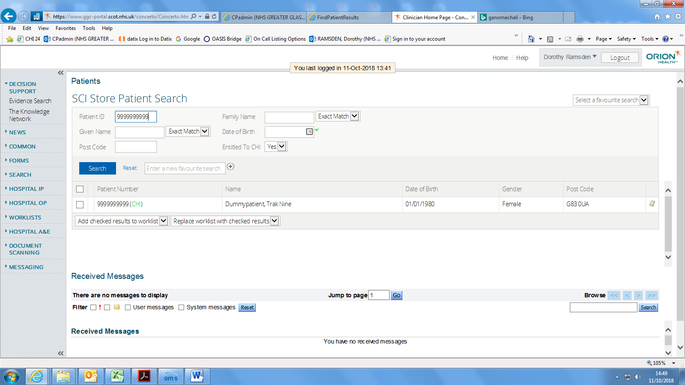

Select Forms & Pathways TAB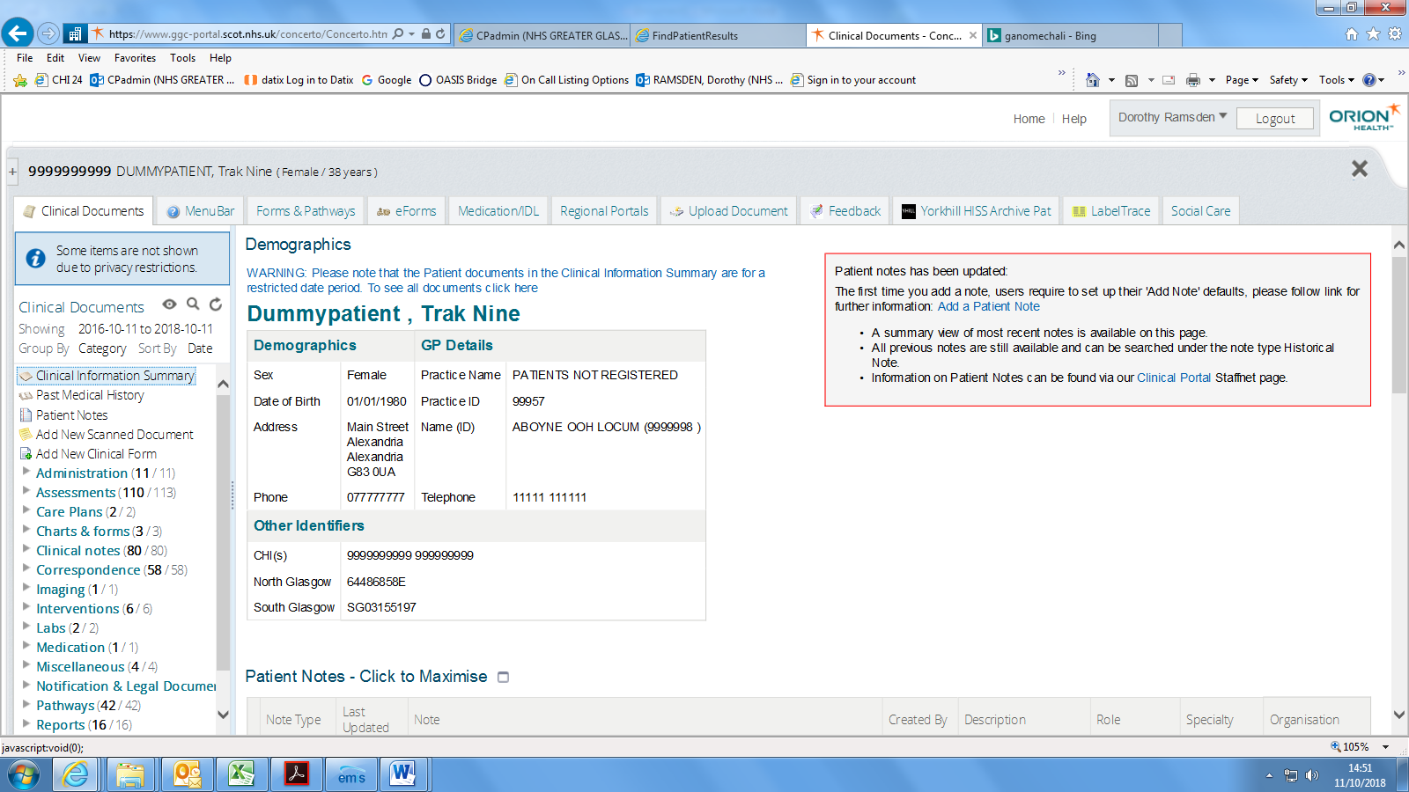

Select add new form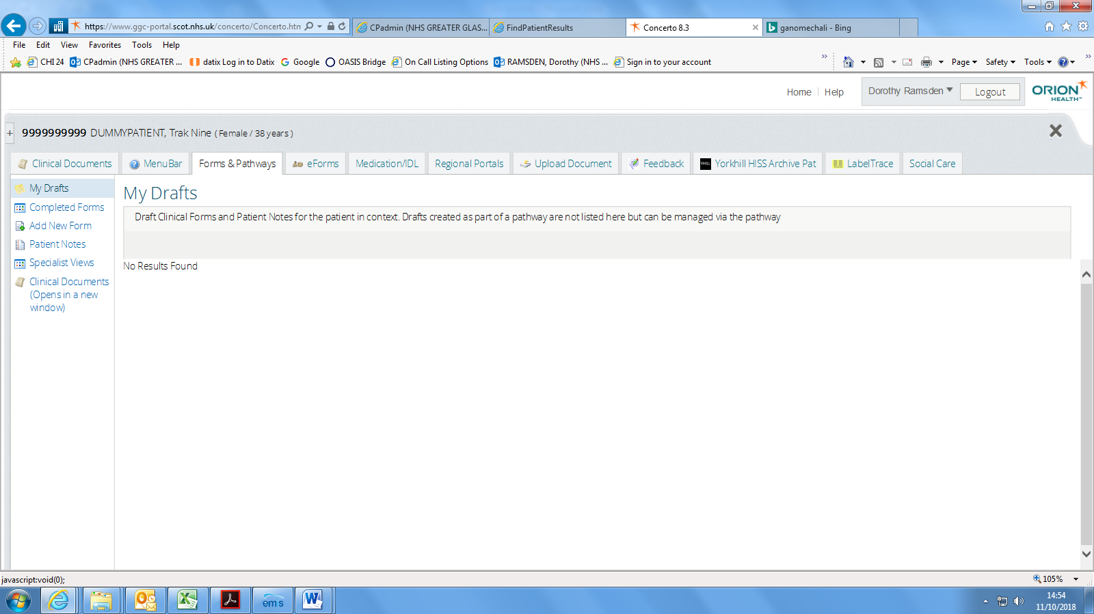

Type in Notification of Concern and click search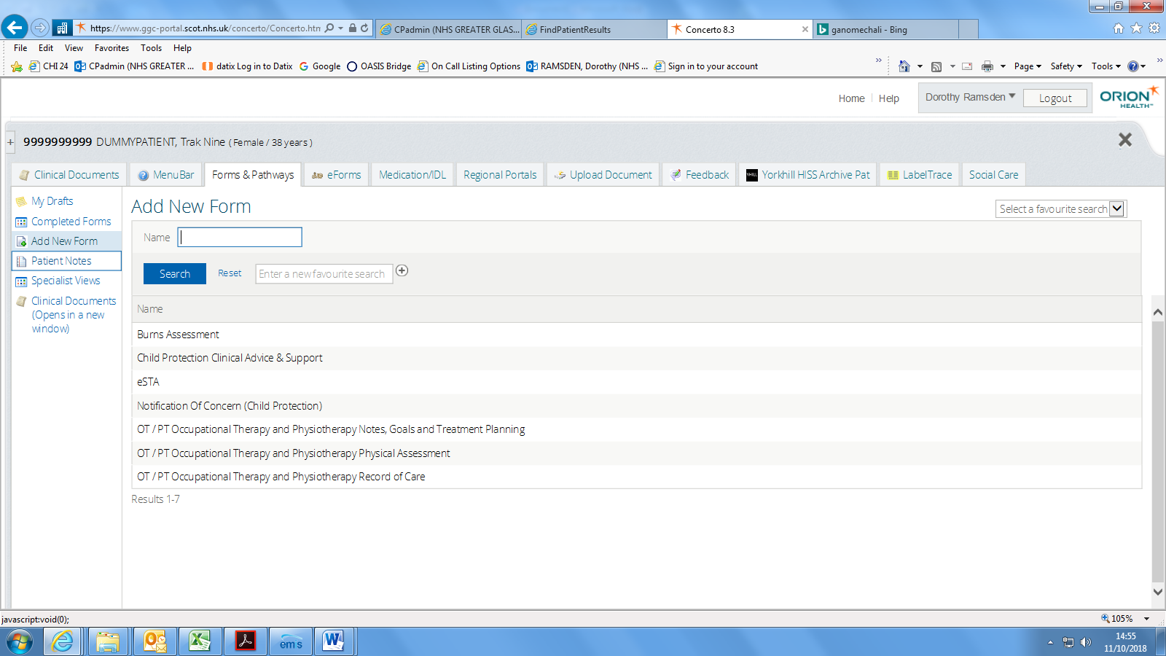

Click on the notification of concern option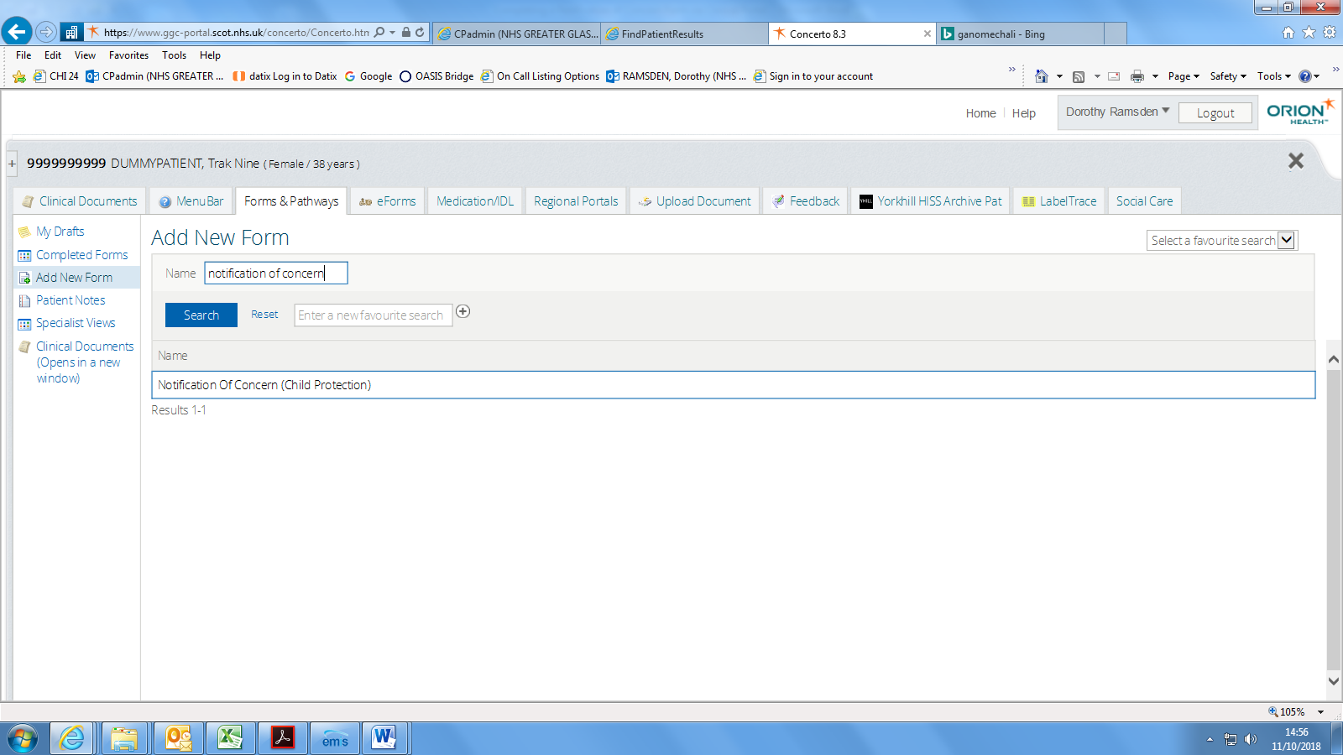

Complete the form with as much information as possible 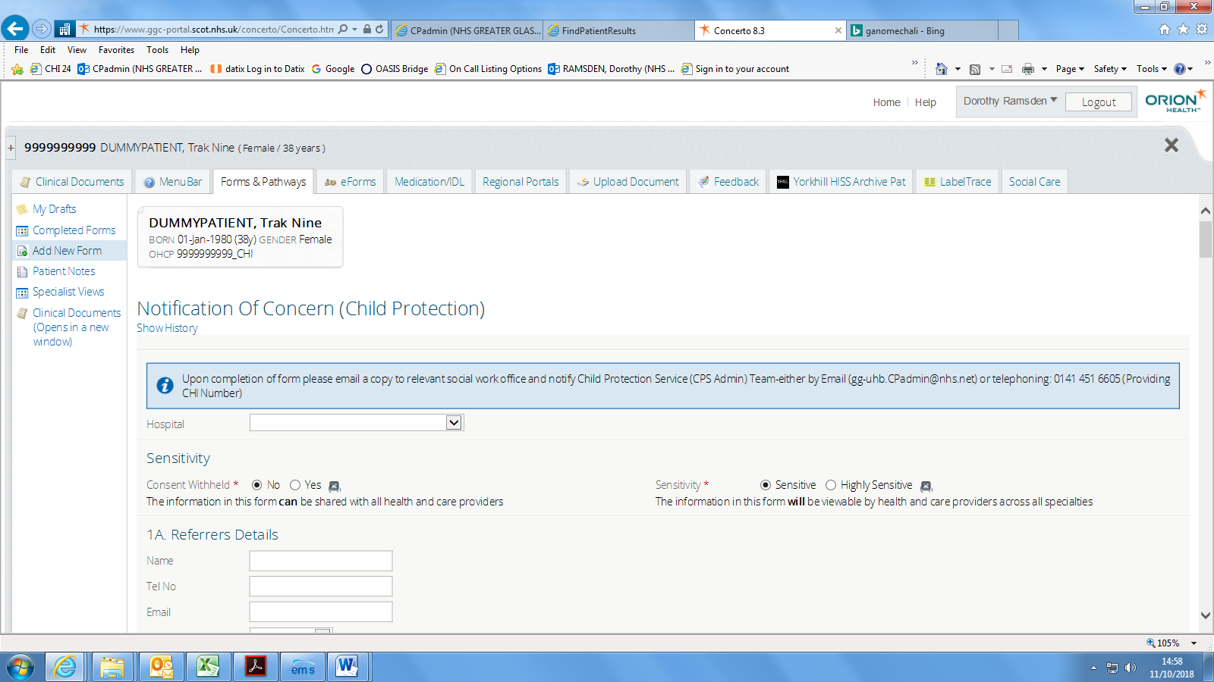

Once all information is entered click on complete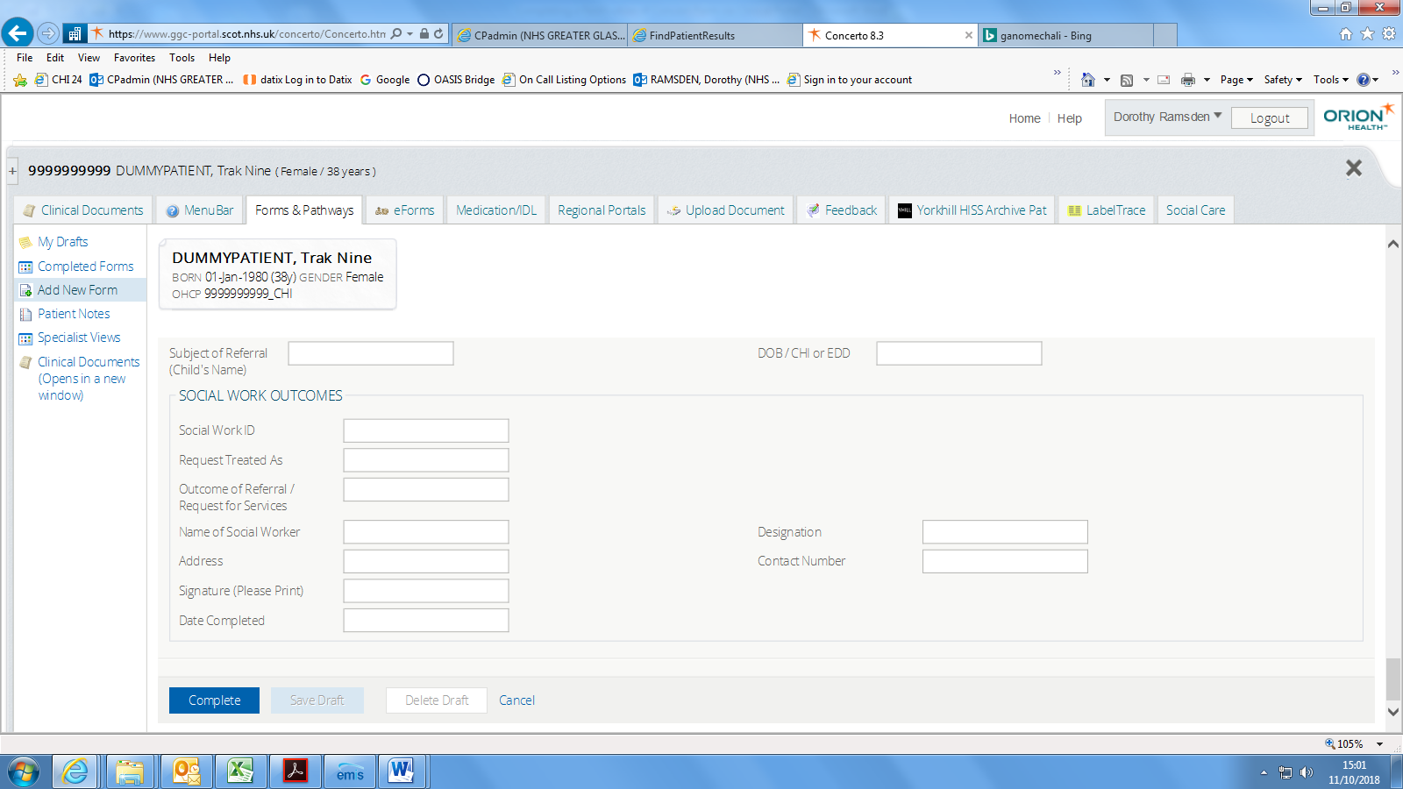
The form will save into the clinical documents, CPA assessment and the date.
Click on correct date and document will open up in right hand side.
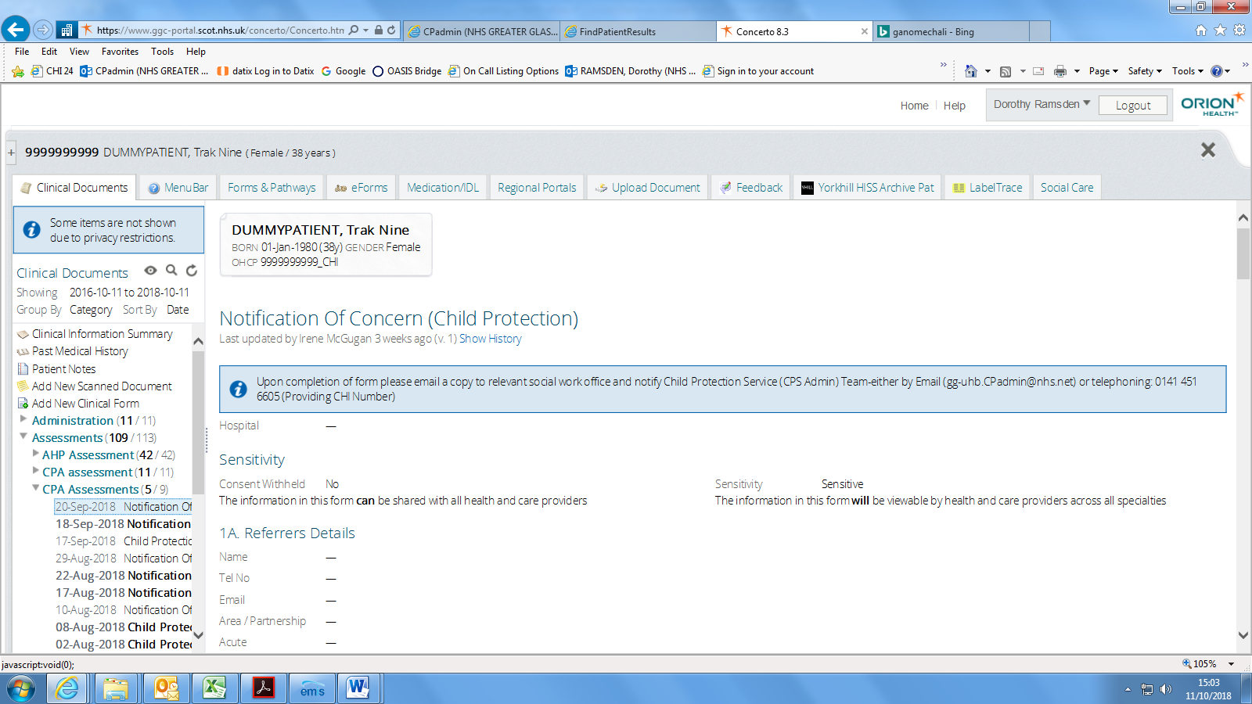

Scroll to bottom of document and click on the print button – the document should open again but back at the top of the document.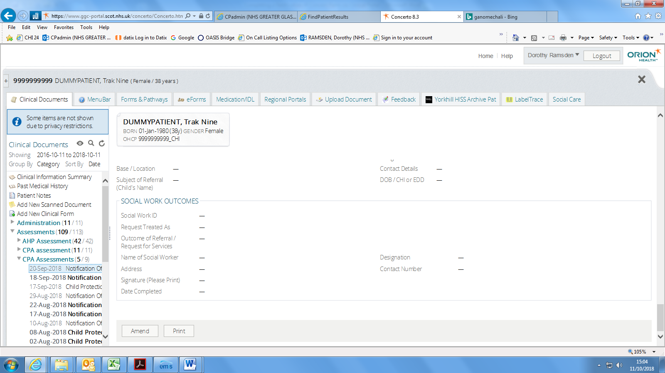

You will now see a small tool bar, click on the save button and save the document in an appropriate place within you’re my documents.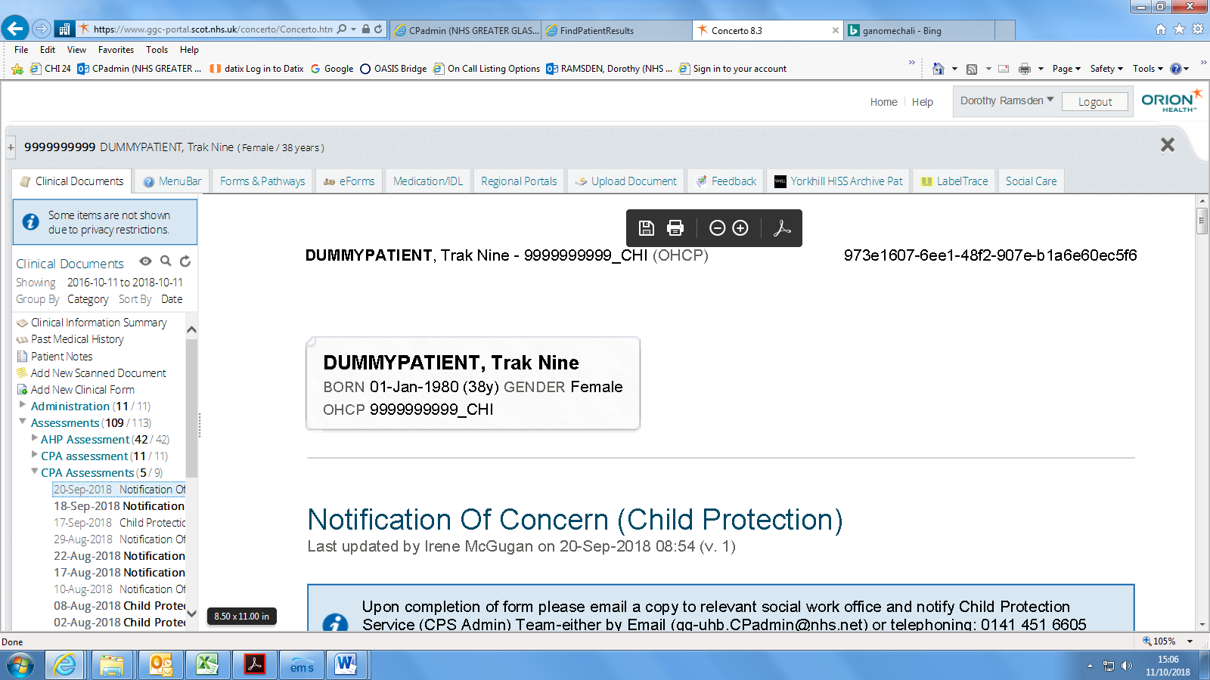
You can now open an email and attached the completed NOC and send to appropriate services.

